UNIT 1 : BACK TO SCHOOL (cont.)
Period 4 ( A3 + A5)

3. Listen. Then practice with a partner. (p.12)
Look at the picture. This is Nga, a new student, and this is Mr. Tan, a teacher .

Nga meets Mr.Tan in the morning. Listen to the dialogue between Nga and Mr. Tan . What does Nga say to her teacher when she meets him ?

- Nga : Good morning, Mr. Tan.
- Mr. Tan : Good morning, Nga. How are you?
- Ba : I’m very well, thank you. And you?
- Mr. Tan : I’m fine, thanks. Good bye. See you later.
- Nga : Goodbye.
Vocabulary:
- hurry (v) /h ʌ ri/ : vội vàng
Ex.: Don’t hurry, there is a lot of time.
- hurry (n) : sự vội vàng
Ex.: Is there any hurry?
- ready (adj.) /’redi/ : sẵn sàng
= prepared
= available
*Good morning/afternoon/evening: dùng để chào người lớn tuổi hơn khi gặp vào các buổi tương ứng.
*Hi/Hello: dùng để chào trong những trường hợp thân mật (bạn bè).

5. Listen. Write the letters of the dialogues in the order you hear (p.13)
Look at the 4 pictures and tell me :
- Where are they ?
- What do you think they will say ?

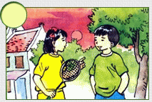
b)
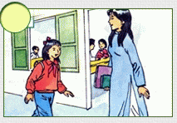
c)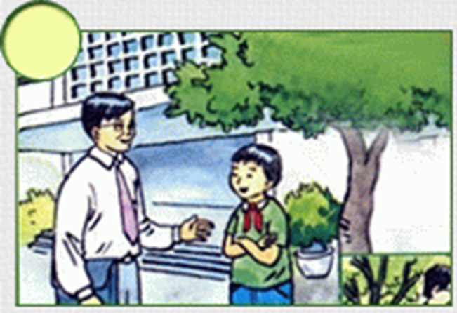

d)
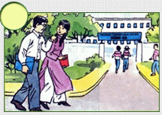
Now, listen to the 4 conversations and write the number in the order you hear.

